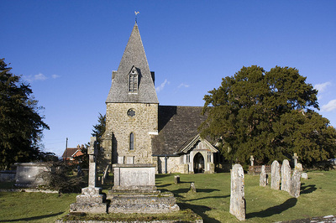

SEPTEMBER SERVICES 2019

Sunday 1st September *The eleventh Sunday after Trinity* 8am Holy Communion (BCP) 10am Family Communion

Sunday 8th September *The twelfth Sunday after Trinity* 8am Holy Communion (BCP) 10am Parish Communion

Sunday 15th September *The thirteenth Sunday after Trinity* 8am Holy Communion (BCP) 10am Parish Communion

Sunday 22nd September *The fourteenth Sunday after Trinity* 8am Holy Communion (BCP) 10am Parish Communion

Sunday 29th September *The fifteenth Sunday after Trinity* 8am Holy Communion (BCP) 10am Parish Communion

Sunday 6th October *The sixteenth Sunday after Trinity* 8am Holy Communion (BCP) 10am Family Harvest Communion

BCP is the Book of Common Prayer (1662)*.* All other Eucharistic Services are from Common Worship: Order One*.* We welcome everyone warmlyand families and children are always welcome at all our services.