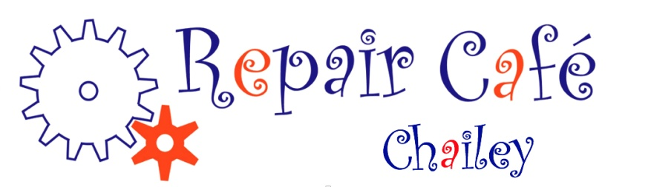

PRESS RELEASE JULY 2021 – CHAILEY REPAIR CAFE

OFF TO A FLYING START!

Chailey Repair Cafe are delighted to announce that we have reopened at our new base in St Peter’s Church Chailey, on the A275 at Chailey Green and will be there on the second Saturday of each month as usual between 1000hrs and 1300hrs

This first face to face Repair Café on Saturday 12th June was a huge success – we got through nearly 50 repairs and were very glad to see that you’d not forgotten about us!!

Regretfully, until all the Government restrictions are lifted, we are still unable to offer a café facility when we open again on July 10th. We are now very hopeful that normal service – with our legendary cakes! - will resume when we reopen fully on 14th August – watch this space!

Don’t forget that we repair portable domestic items only and we try to do that while you wait and watch what we do, so you’ll be able to fix it yourself next time!!

Please don’t leave items for repair at the Church when we are not there!! Come and see us when we are open, or contact us at chaileyrc@gmail.com and we’ll see what we can do to help.

See you very soon!!

Bryan McAlley and the Chailey Repair Café team

--------------------------------------------------------------------------------------------------------------

