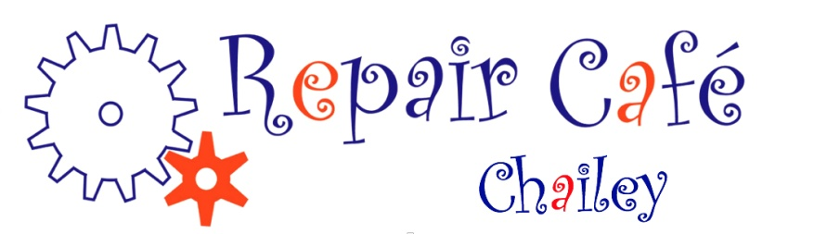

PRESS RELEASE APRIL 2021 – CHAILEY REPAIR CAFE

NEARLY THERE!

We are very pleased to be able to tell you that we have now set provisional dates for our gradual reopening this summer! Our superb new base at St Peter’s Church Chailey has been transformed and we are looking forward to once more being able to see you all face to face. The first Repair Café of 2021 will be for “drop off” repairs only. You’ll be able to talk through the problem with one of the team and we’ll take the repair away and let you know when it’s ready for collection. More about that, with dates, soon!

Meanwhile, keep bringing us your repairs! The way it works is that we put your repair enquiry out to our volunteers and anyone who is prepared to take it on agrees to do so. They then make contact with you and give you their address. You drop it on their doorstop and they tell you when it’s fixed. You then collect it, paying for any parts required, and we invite you to make a donation toward the Cafe... That’s all there is to it!!

Please note that we cannot visit you at home, and can only take on easily portable items, so no dishwashers, freezers or stuck container ships please!!!

And – do try to say a bit more than “my toaster is broken”!! Help us to help you by taking the time to tell us the make and model number of the item, exactly what has gone wrong, send us a good quality photo or two, and we will see what we can do. Sorry, but only one repair at a time please, as we are seriously busy right now!

Contact us at chaileyrc@gmail.com

Bryan McAlley and the Chailey Repair Café team

--------------------------------------------------------------------------------------------------------------

