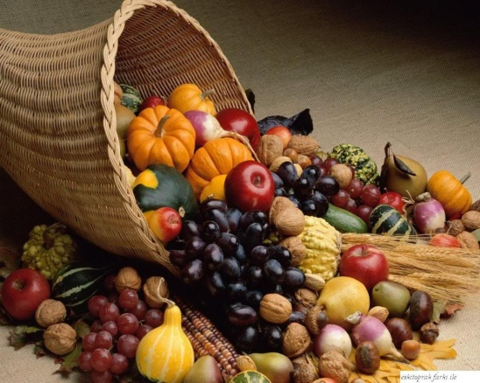

 OCTOBER

SERVICES 2016

Sunday 2nd October *The nineteenth Sunday after Trinity* 8am Holy Communion (BCP) 10am Parish Communion

Sunday 9th October *The twentieth Sunday after Trinity* 8am Holy Communion (BCP) 10am Harvest Family Service

Sunday 16th October *The twenty first Sunday after Trinity* 8am Holy Communion (BCP) 10am Parish Communion

Sunday 23rd October *The twenty second Sunday after Trinity* 8am Holy Communion (BCP) 10am Parish Communion

Sunday 30th October *The twenty third Sunday after Trinity* 8am Holy Communion (BCP) 10am Parish Communion

Sunday 6th November *The twenty fourth Sunday after Trinity*

8am Holy Communion 10am All age family service

BCP is the Book of Common Prayer (1662)*.* All other Eucharistic Services are from Common Worship: Order One*.* We welcome everyone warmlyand families and children are always welcome at all our services.