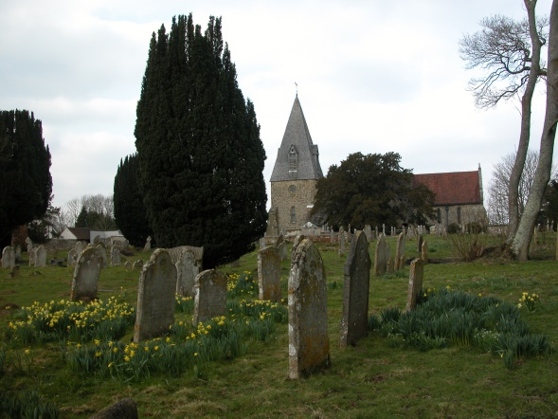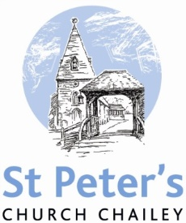

**NOVEMBER SERVICES 2020**

**THE FOLLOWING SERVICES WILL BE HELD IN ST MARTIN’S CHAPEL CHAILEY HERITAGE UNTIL 27th November**

**Sunday 1st November *The All Saints Day*** 10am Family Communion

**Sunday 8th November *Remembrance Sunday*** 10.50am Remembrance service at the war memorial (Not the Heritage)

**Sunday 15th November** ***The second Sunday before Advent*** 10am Parish Communion S**unday 22nd November *Sunday next before Advent*** 10am Parish Communion

**HOPEFULLY NOW BACK AT SAINT PETER’S**

**Sunday 29th November *Advent Sunday*** 10am Parish Communion

**Sunday 6th December *The second Sunday of Advent***  8am Holy Communion (BCP) 10am Christingle

**BCP is the Book of Common Prayer (1662)*.* All other Eucharistic Services are from Common Worship: Order One*.* We welcome everyone warmlyand families and children are always welcome at all our services.**

BCP is the Book of Common Prayer (1662)*.* All other Eucharistic Services are from Common Worship: Order One*.* We welcome everyone warmlyand families and children are always welcome at all our services.