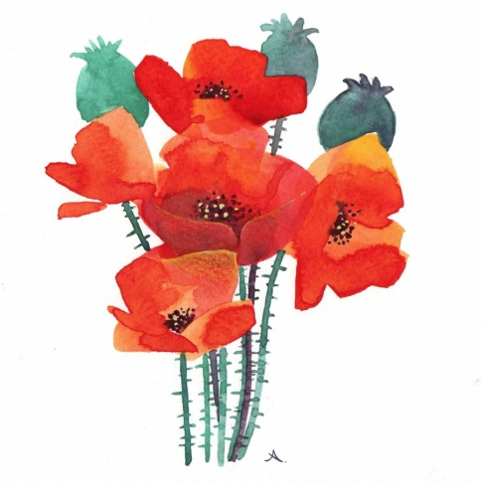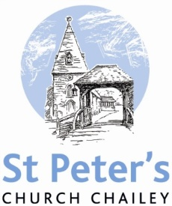

NOVEMBER SERVICES

2018

Sunday 4th November *The fourth Sunday before Advent* 8am Holy Communion (BCP) 10am Family Communion

Sunday 11th November *The third Sunday before Advent* 8am Holy Communion (BCP) 10.50am REMEMBRANCE SERVICE beginning at the war memorial

Sunday 18th November *The second Sunday before Advent* 8am Holy Communion (BCP) 10am Parish Communion

Sunday 25th November *The Sunday next before Advent* 8am Holy Communion (BCP) 10am Parish Communion

Sunday 2nd December *Advent Sunday* 8am Holy Communion (BCP) 10am Family Communion

BCP is the Book of Common Prayer (1662)*.* All other Eucharistic Services are from Common Worship: Order One*.* We welcome everyone warmlyand families and children are always welcome at all our services.