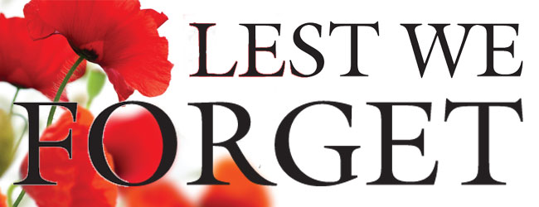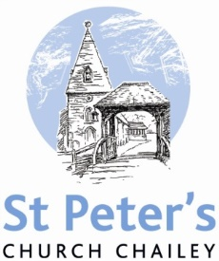

NOVEMBER SERVICES 2017

Sunday 5th November *The fourth Sunday before Advent*  8am Holy Communion (BCP) 10am Family Communion

Sunday 12th November *The third Sunday before Advent REMEMBRANCE SUNDAY* 8am Holy Communion (BCP) 10.50 am Remembrance Service (starting at the war memorial)

Sunday 19th November *The second Sunday before Advent* 8am Holy Communion (BCP) 10am Parish Communion

Saturday 25th November 10am-2pm Christmas Market

Sunday 26th November *The Sunday next before Advent* 8am Holy Communion (BCP) 10am Parish Communion

Sunday 3rd December *Advent Sunday* 8am Holy Communion (BCP) 10am Family Communion

BCP is the Book of Common Prayer (1662)*.* All other Eucharistic Services are from Common Worship: Order One*.* We welcome everyone warmlyand families and children are always welcome at all our services.