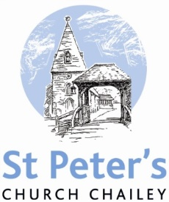

MAY SERVICES

2018

Sunday 6th May *The sixth Sunday of Easter* 8am Holy Communion (BCP) 10am Family Communion

Thursday 10th May *Ascension Day* 7pm Ascension Day service at Newick

Sunday 13th May *The Sunday after Ascension Day* 8am Holy Communion (BCP) 10am Parish Communion

Sunday 20th May *PENTECOST* 8am Holy Communion (BCP) 10am Parish Communion

Sunday 27th May  *TRINITY SUNDAY* 8am Holy Communion (BCP) 10am Parish Communion

Sunday 3rd June *The first Sunday after Trinity* 8am Holy Communion (BCP) 10am Family Communion

BCP is the Book of Common Prayer (1662)*.* All other Eucharistic Services are from Common Worship: Order One*.* We welcome everyone warmlyand families and children are always welcome at all our services.