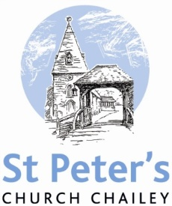

MAY SERVICES 2017

Sunday 7th May *Fourth Sunday of Easter* 8am Holy Communion (BCP) 10am Family Communion

Sunday 14th May *The fifth Sunday of Easter* 8am Holy Communion (BCP) 10am Parish Communion

Sunday 21st May *The sixth Sunday of Easter* 8am Holy Communion (BCP) 10am Parish Communion Thursday 25th May *Ascension Day* 7pm Service at St Mary’s, Newick

Sunday 28th May *The seventh Sunday of Easter* 8am Holy Communion (BCP) 10am Parish Communion

Sunday 4th June *Whit Sunday* 8am Holy Communion (BCP) 10am Family Communion

BCP is the Book of Common Prayer (1662)*.* All other Eucharistic Services are from Common Worship: Order One*.* We welcome everyone warmlyand families and children are always welcome at all our services.