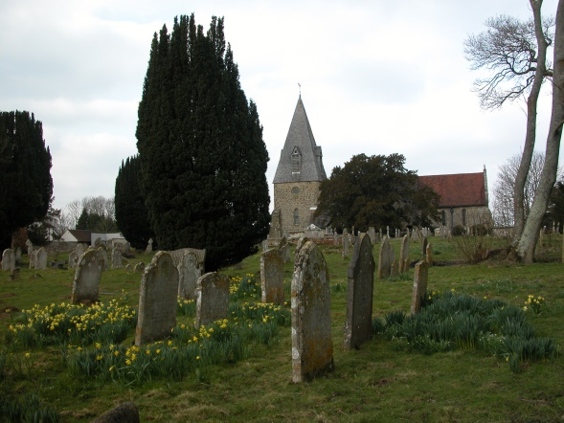

**MARCH SERVICES 2020**

**Sunday 1st March *The first Sunday of Lent***8am Holy Communion (BCP) 10am Family Communion

**Sunday 8th March *The second Sunday of Lent*** 8am Holy Communion (BCP) 10am Parish Communion

**Sunday 15th March *The third Sunday of Lent*** 8am Holy Communion (BCP) 10am Parish Communion

**Sunday 22nd March *The fourth Sunday of Lent MOTHERING SUNDAY*** 8am Holy Communion (BCP) 10am Mother’s Day Communion

**Sunday 29th March *The fifth Sunday of Lent*** 8am Holy Communion (BCP) 10.00am Parish Communion

**Sunday 5th April** ***Palm Sunday*** 8am Holy Communion (BCP) 10am Palm Sunday Communion

**BCP is the Book of Common Prayer (1662)*.* All other Eucharistic Services are from Common Worship: Order One*.* We welcome everyone warmlyand families and children are always welcome at all our services.**

BCP is the Book of Common Prayer (1662)*.* All other Eucharistic Services are from Common Worship: Order One*.* We welcome everyone warmlyand families and children are always welcome at all our services.