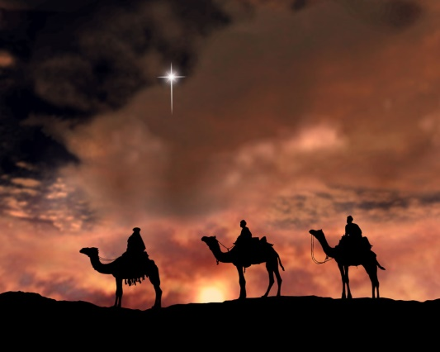

**JANUARY SERVICES 2020**

**Sunday 5th January *The second Sunday of Christmas*** 8am Holy Communion (BCP) 10am Family Communion

**Sunday 12th January *The first Sunday after Epiphany*** 8am Holy Communion (BCP) 10am Morning Prayer

**Sunday 19th January *The second Sunday of Epiphany***8am Holy Communion (BCP) 10.00am Parish Communion

**Sunday 26th January *The third Sunday of Epiphany***8am Holy Communion (BCP) 10am Parish Communion

**Sunday 2nd February *Presentation of Christ in the temple*** 8am Holy Communion (BCP) 10am Family Communion

**BCP is the Book of Common Prayer (1662)*.* All other Eucharistic Services are from Common Worship: Order One*.* We welcome everyone warmlyand families and children are always welcome at all our services.**

BCP is the Book of Common Prayer (1662)*.* All other Eucharistic Services are from Common Worship: Order One*.* We welcome everyone warmlyand families and children are always welcome at all our services.