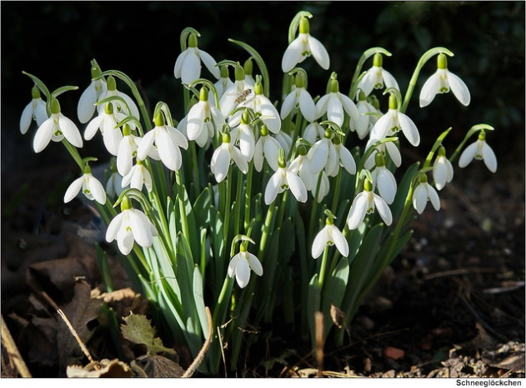

FEBRUARY SERVICES 2019

Sunday 3rd February *The fourth Sunday after Epiphany*

8am Holy Communion (BCP) 10am Family Communion

Sunday 10th February *The fourth Sunday before Lent* 8am Holy Communion (BCP) 10am Parish Communion

Sunday 17th February *The third Sunday before Lent* 8am Holy Communion (BCP) 10am Parish Communion

Sunday 24th February *The second Sunday before Lent*  8am Holy Communion (BCP) 10am Parish Communion

Sunday 3rd March *The Sunday next before Lent* 8am Holy Communion (BCP) 10am Family Communion

BCP is the Book of Common Prayer (1662)*.* All other Eucharistic Services are from Common Worship: Order One*.* We welcome everyone warmlyand families and children are always welcome at all our services.