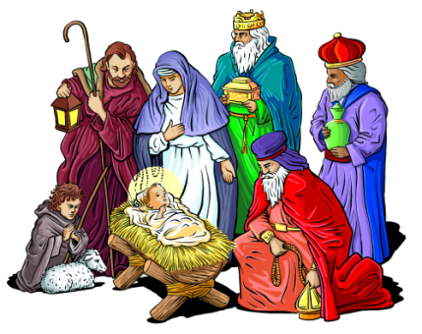

DECEMBER SERVICES 2018

Sunday 2nd December *Advent Sunday* 8am Holy Communion (BCP)

10am Family Communion

Sunday 9th December *The second Sunday of Advent* 8am Holy Communion (BCP) 10am Christingle

Sunday 16th December *The third Sunday of Advent* 8am Holy Communion (BCP) 10am Parish Communion 6pm Carol Service

Sunday 23rd December *The fourth Sunday of Advent* 8am Holy Communion (BCP) 10am Parish Communion

Monday 24th December *Christmas Eve* 3pm Crib Service 11pm Midnight Communion

Tuesday 25th December *CHRISTMAS DAY* 8am Holy Communion (BCP) 10am Christmas Family service

Sunday 30th December *The second Sunday of Christmas* 8am Holy Communion (BCP) 10am Parish Communion

Sunday 6th January *Epiphany* 8am Holy Communion (BCP) 10am Family Communion

BCP is the Book of Common Prayer (1662)*.* All other Eucharistic Services are from Common Worship: Order One*.* We welcome everyone warmlyand families and children are always welcome at all our services.