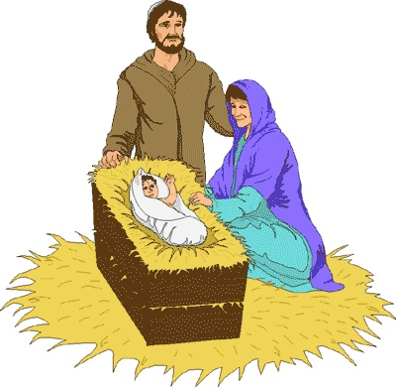

DECEMBER SERVICES 2017

Sunday 3rd December *Advent Sunday* 8am Holy Communion (BCP) 10am Family Communion

Sunday 10th December *The second Sunday of Advent*  8am Holy Communion (BCP) 10am Parish Communion

Sunday 17th December *The third Sunday of Advent* 8am Holy Communion (BCP) 10.00 am Children’s Christingle Service 6pm Carol Service

Sunday 24th December *The fourth Sunday Advent* 8am Holy Communion (BCP) 10am Parish Communion 3.30pm CRIB SERVICE 11.30pm Midnight Communion

Monday 25th December *CHRISTMAS DAY* 8am Holy Communion (BCP) 10am Christmas Day Family Service

Sunday 31st December *New Years Eve* 8am Holy Communion (BCP) 10am Parish Communion

BCP is the Book of Common Prayer (1662)*.* All other Eucharistic Services are from Common Worship: Order One*.* We welcome everyone warmlyand families and children are always welcome at all our services.