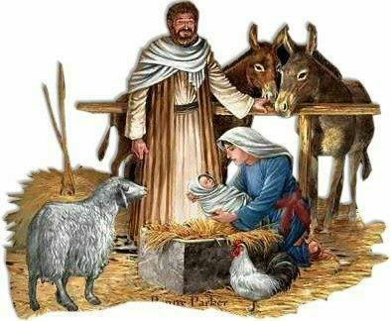

DECEMBER SERVICES 2016

Sunday 4th December *The* *Second Sunday of Advent* 8am Holy Communion (BCP) 10am Parish Communion

Sunday 11th December *The third Sunday of Advent* 8am Holy Communion 10am Children’s Christingle

Sunday 18th December *The fourth Sunday of Advent* 8am Holy Communion (BCP) 10.00am Parish Communion 6pm Nine Lessons and Carols

Saturday 24th December *Christmas Eve* 3.30pm Children’s Crib Service 11.30pmMidnight Communion

Sunday 25th December *CHRISTMAS DAY* 8am Holy Communion (BCP) 10am Christmas Family Service

Sunday 1st January *The second Sunday of Christmas* 8am Holy Communion (BCP) 10am Parish Communion

BCP is the Book of Common Prayer (1662)*.* All other Eucharistic Services are from Common Worship: Order One*.* We welcome everyone warmlyand families and children are always welcome at all our services.