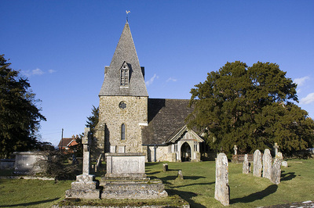

AUGUST SERVICES 2019

Sunday 4th August *The seventh Sunday after Trinity* 8am Holy Communion (BCP) 10am Family Communion

Sunday 11th August *The eighth Sunday after Trinity* 8am Holy Communion (BCP) 10am Parish Communion

Sunday 18th August *The ninth Sunday after Trinity* 8am Holy Communion (BCP) 10am Parish Communion

Sunday 26th August *The tenth Sunday after Trinity* 8am Holy Communion (BCP) 10am Parish Communion

Sunday 1st September *The eleventh Sunday after Trinity*  8am Holy Communion (BCP) 10am Family Communion

BCP is the Book of Common Prayer (1662)*.* All other Eucharistic Services are from Common Worship: Order One*.* We welcome everyone warmlyand families and children are always welcome at all our services.